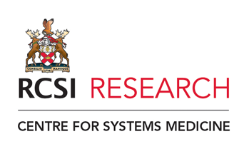

**Registration for 3 day Mini Science TY programme 2025**

Dates: 18th 19th and 20th of March 2025

Name of Student…………………………………………………………………………....................................

Email address of Student………………………………………………………………………………………………

Name of School………………………………………………………………………………………..

Address of school………………………………………………………………………………………………………………………………………………………

Name and phone number of career guidance or science teacher to contact if needed

…………………………………………………………………………………………………………………………………………………………………

…………………………………………………………………………………………………………………………………………………

Mobile Number of student if applicable…………………………………………………………………………………………..

How did you hear about the programme?

Reason why you would like to attend the programme (100 words)

Some talks may be recorded and pictures may be taken, for dissemination purposes (CSM webpage, and reporting to funding agencies)

Are you ok with that? Yes or No